Kol Simcha Torah Gazette
For parshamikeitz/
chanuakah 5785
Volume 9 Issue 14 (Whole #428) 27 Kislev 5785/ December 28, 2024
Printed L’illuy nishmas Nechama bas R’ Noach, a”h

For a free subscription, please forward your request to keren18@juno.com
Past emails can be found on the website ShabbosStories.com under Brooklyn Torah Gazette

Listen to the Flames
By Rabbi Simon Jacobson

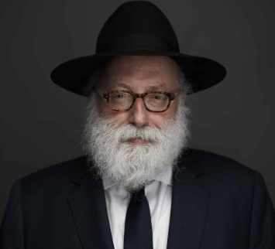

If we look closely at the details of Chanuka - the Menora, the history, the number of flames - they can reveal the nature of our soul.
As the sun sets and the shadows of night descend, we kindle the Menora creating light in the darkness. Listen carefully to the flames and they will tell you a story, a story that will empower you to live a more profound meaningful life, enabling you to rise up toward challenge and overcome difficulty. Sit near the flames and study them quietly.
"The flame of G-d is the soul of a human being," says the Torah. As flames warm and illuminate their environment, so too you can use your soul to infuse life with warmth and light. Unlike all other physical entities that are drawn earthward, the dancing flames flicker upward defying gravity. Likewise, your soul, not satisfied with mere physical comforts, aspires up toward something beyond.
Chanuka is not just about lighting up our own lives. By placing the Menora in the window of your home or at your doorpost, you allow the light to radiate into the dark street, illuminating your surroundings. Chanuka reminds us of our ability and responsibility to affect the world around us and prompts us to shine light into the lives of others with daily acts of goodness and kindness. Just as a flame lights another without diminishing itself, so too by sharing yourself you become enhanced rather than diminished. Every day we must increase illumination of ourselves and our environment - each day adding another good deed, lighting an additional flame.
Chanuka tells yet a deeper story, a story that penetrates the darker shadows of our lives. The Menora shines a tunnel back through time to the aftermath of a great victory in which a small band of Jews defeated the might of the Greek Empire.
In amongst the debris of the desecrated Temple the Maccabees searched ceaselessly until they found a single sealed cruse of oil that miraculously burnt for eight days. When you are defiled, when your inner Temple has been desecrated and there is no oil to be found, you have the power to reach deeper inside and discover light.
The soul always remains intact like a "pilot light." When you light your Menora under such difficult circumstances, creating light in the darkest moment, that light can never be extinguished. The light that has dealt with challenge, that has transformed pain into growth, is a light that transcends nature and transforms darkness into light.
This power to transform darkness must come from a place beyond the conventional. We therefore light eight candles, the mystical number of transcendence and infinity, one beyond the number seven that represents the natural cycle. In order to pierce darkness with light, you can't just rely on the natural, you need to reach a deeper resource which is the eighth dimension.
These elements of Chanuka - the eight flickering flames, the miracle of the oil, the light shining into the dark street - beckon us to connect to the power of our soul. Our soul rises like a flame toward that which transcends itself, not only repelling darkness as is the nature of all light, but transforming the darkness into light.

Rabbi Jacobson is the author of Toward a Meaningful Life and founder and director of The Meaningful Life Center: - www.meaningfullife.com

Rav Avigdor Miller on
How Not to Despair About One’s Torah Learning
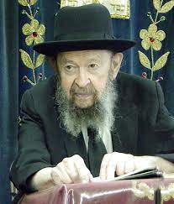
I suppose it means that he thinks that it’s too much for him to do and he gives up hope; he gives up hope of succeeding in knowing Torah.
We’ll take an analogy. As you walk on Kings Highway, you see big establishments. There are some big businesses there, successful stores. But on one street corner, there’s a man with a peanut stand. It’s a simple cart; two wheels, that’s all, and there’s a little stove that’s heating the peanuts. And this man is standing there and waiting for customers.
Now, they’re not standing in line for him. Customers are few and far between. And sometimes it’s cold too. Does he give up? No. Why doesn’t he give up? Because he wants as much as he can earn. He can earn three dollars a day, five dollars a day, he’s satisfied. Of course, he’d like to earn five thousand dollars a day but when it comes to money, however, you earn as much as you’re able. And he’s quite happy if he takes home five dollars at the end of the day.
When it comes to learning, all of a sudden nobody wants to learn for peanuts. Everybody wants to be a millionaire. “If I cannot be a gadol hador, then I don’t want to learn.” He gives up. I had a case like that. He said, “I can’t become a gadol, so what’s the use?”
No! If you can learn one line a day it’s a success! You learn two lines? A bigger success! Learn whatever you can and that’s a great achievement. It’s only the yetzer hara that tells you either you learn for the highest stakes or don’t learn at all. It’s a deception and many people allow themselves to be persuaded by that. It’s remarkable how much people can accomplish if they learn little by little. In the course of time, it adds up to a great amount of wealth!

Reprinted from the Parshas Vayeishev email of Toras Avigdor, - (Tape #307 – March 1980)

The Surgeon and
the Murderer

And their camels bearing spices, balsam and lotus” (Bereishis 37:25)
Rashi explains that the Yishme’alim would generally transport goods that had a foul-smelling odor. However, when Yosef was sold and transported to Mitzrayim, he merited that the caravan in which he was transported was carrying goods with a pleasant aroma. But what is the significance of this small “comfort” when one is being carted off to servitude?
The Telzer approach, attributed to Rav Mottel Pogremonski zt’l, explains this with a parable. Both a surgeon and a murderer bring a knife to the skin. Yet the distinction between the one that seeks to heal and the one that seeks to injure is observed in the surgeon’s meticulousness and delicate approach. Although Yosef was being cast away, it was ultimately for the later good; a “Refuah Kodem La’makkah”. This small detail of the pleasant aroma despite the circumstances demonstrates that the master plan was perfect and meticulous.
In a similar vein, Rav Chaim Shmuelevitz explains that this pleasant aroma was Hashem’s message to Yosef that He is with him in his suffering. On Chanukah we recognize and express our gratitude for the miracles performed. Along with the great miracles of the times of the Chashmonaim, we also need to recognize the many smaller miracles that take place in our times and get a good “scents” of all the everyday blessings in our lives.

Reprinted from the Parshas Vayeishev 5785 email of Klal Govoah’s “Tidbits”

The Significance of
the Word “Chalila”
From the Teachings of the Lubavitcher Rebbe
Rabbi Menachem Mendel Schneerson, Zt”l

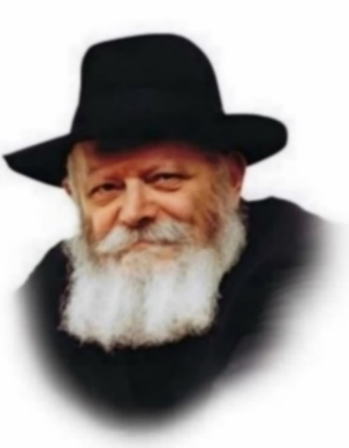

In the Torah portion of Mikeitz, Joseph orders his servants to hide his goblet in his brother's bags. He then sends a messenger to overtake them on the road. When the brothers learn that they are accused of stealing, they reply, "Far be it ("chalila") from your servants to do such a thing!"
One of the explanations offered by Rashi on the word "chalila," which is generally translated as "G-d forbid" or "heaven forefend," is derived from its root in the word "chulin," meaning profane or derogatory. The word also connotes common, i.e., anything that is not related to holiness.
The brother's reply to Joseph's messenger thus not only denied their participation in the theft, but expressed a much deeper concept: that the very idea of their involvement in anything other than the realm of holiness was absurd. In other words, the brothers were on such a high spiritual level that relating to the mundane, physical world was somehow incongruous.
Each one of the Twelve Tribes embodied a different path in the service of G-d. And while not every individual Jew is blessed with all of their unique character attributes, there are certain general aspects of their service that we all share in common. The brothers' declaration of "chalila" thus contains a practical lesson to be applied in our daily lives.
A Jew must know that his entire being - his very essence - is holiness. The Jew and the secular realm are two entirely different worlds. The mundane level of existence does not truly pertain to the Jew, to the point that involvement in the material realm is essentially foreign to him.
This extremely high level is not only something the Jew must feel inwardly, but must also be reflected in all of its external manifestations. The nations of the world should be able to see that, to the Jew, the very notion of "mundane" is just as incongruous as the notion of stealing. Indeed, it is this concept that was proudly articulated by Joseph's brothers to the Egyptian messenger.
Of course, the Torah commands that a Jew work within the framework of the physical world. "Six days shall you labor, and do all your work." But the intention is not that the Jew lower himself to the level of the profane; on the contrary, it implies the exact opposite. A Jew is required to involve himself in the world for the purpose of elevating the material plane of existence to holiness. This demonstrates that all his deeds are for the sake of heaven, and brings sanctity into the world.

Reprinted from Parshat Mikeitz 5762/2001 edition of L’Chaim, a publication of the Lubavitcher Youth Organization. Adapted from Volume 15 of Likutei Sichot

A Chinese Celebrity’s Conversion to Judaism
By Yehudis Litvak


A Chinese TV reporter applied her investigative methods to the Bible and decided to convert to Judaism before she ever stepped foot in a synagogue.
Growing up in Communist China, Hong Zheng was not familiar with any religion, nor had she ever met a Jew. She’d heard about Jews as a nation. “Chinese people usually have a good impression of the Jewish people,” she says. “They believe that Jews are very good with money.” But she didn’t even know that Jews had their own religion.
When Hong was a teenager, the communist leader Mao Zedong died. His replacement, Deng Xiaoping, was more tolerant towards religion. The only religion easily available to Hong’s family in China was Buddhism.
Spiritual by nature, Hong was drawn to Buddhism. She recalls, “I believed that there was a Superpower in charge of the world and Buddhism offered that.” But she was confused about why Buddhism had so many gods. Why was it necessary to turn to one god for help with fertility and another god for help with finances? “I felt that something was off,” she says. “A country cannot have two kings – that would be chaos. Imagine a world with more than one king!”
Though not fully satisfied with her spiritual life, Hong was very successful professionally. She had graduated university as a registered nurse but found that she did not enjoy western medicine, which was too much about memorization and too little about intuition. Instead, she found a job at the university’s radio station.
After receiving many compliments for her professional “radio voice,” Hong decided to enter a TV show host contest. She won first prize and embarked on a TV career, hosting TV shows, producing her own original shows, and broadcasting daily news. Fed up with the communist nature of Chinese TV shows and the need to know the “right people,” Hong switched to investigative reporting. She enjoyed analyzing various subjects, asking complex questions and getting to the bottom of the subject at hand. She received many awards for her work. Her fame grew and she became a household name in China.

Journey to America
Nevertheless, due to personal and professional challenges, after 13 years in the TV world, Hong decided she needed a break. She signed up for an international conference on freedom of press which was going to take place in Duke University in North Carolina.
This was Hong’s first time in America, and at the time, she did not speak English fluently. The conference organizers hired a Chinese translator for her. “I didn’t feel good about that because I was supposed to represent China,” she says. Hong decided to spend the next six months learning English so she would no longer need translation services at her next conference.
Hong had come to the U.S. on the J-1 exchange scholar visa that was only good for six months. To renew her visa, she had to sign up for another conference. Providentially, the conference she signed up for was about freedom of religion at Seton Hall University in New Jersey.


While Hong studied English and waited for the second conference to begin, a friend introduced her to a Christian minister named Moses. This was Hong’s first encounter with a Christian religious leader and when the minister invited her and her friend over for dinner, she was fascinated to learn about Christianity.
Moses, in turn, was impressed with Hong’s knowledge of Buddhism. They discussed both religions for hours and at the end, Moses said to her, “You are a very spiritual person. G-d is calling you, but you believe in the wrong god.”
The minister’s words stirred the investigative reporter in Hong, and she decided that she needed to learn more about Christianity and investigate which religion was true.
Moses gave Hong a Bible with a Chinese translation, and she began her investigation.
She prayed to the one G-d that she knew ruled the world, even though she wasn’t sure at that point who He was, and she asked Him for guidance. “I had faith that He would show me the right direction,” she recalls.

Investigating Religions
She opened the Bible in a random place. “I was shocked,” she says. “The first sentence I read said, ‘You came from the east.’ Then I was shocked again when I read, ‘But you bow down to idols.’ It was true – I was bowing down every night, 108 times, full body on the floor.” The bowing down is a Buddhist tradition which Hong had practiced for years.
“This is speaking directly to me,” Hong said to herself. “Does this mean Moses was right? Was I believing in the wrong god all this time?”
She continued reading the Bible and came back to Moses with a list of questions. But Moses couldn’t provide Hong with satisfactory answers.
“So, I read more,” she says, “and the more I read the more I felt that the Old Testament made so much sense.”
The New Testament, on the other hand, didn’t meet her strict journalistic standards. For example, Hong read that the Christian messiah claimant had many followers but people in his own hometown did not follow him.
“If you want to investigate about something, you go to the source,” she says. “That’s what I do. I’d investigate from the very bottom all the way up. No matter how you fancy yourself, you can say I’m so and so, but when you go to your hometown, they know who you are. That’s why they didn’t believe him. They didn’t follow him because they knew exactly who he was.”
Hong was also bothered by the fact that, according to the Old Testament, the messiah was supposed to be a descendant of King David, but the New Testament claimed that he was the son of G-d. He couldn’t possibly be both at the same time.
Then Hong learned that Christianity didn’t really become popular until hundreds of years after the supposed messiah’s death. That fact also raised her suspicions as an investigative journalist. “My conclusion was that it was just a story,” she says.
Having ruled out Christianity, Hong looked into other major religions, such as Islam. It did not meet her journalistic standards either.
The Old Testament, on the other hand, continued to draw her in. She found more depth to it than any other religious text. She knew that it was much older than the New Testament and that it has never changed. In response to her many questions, Moses had told her that the Old Testament came from Judaism, which is “the mother of all religions.” Hong wanted to learn more about Jews and Judaism.
She read about the ancestry of the Jewish people in the Bible. She was impressed that Jews could trace their lineage all the way to the beginning of history. She also learned that the burial places of Jewish forefathers and foremothers are known and visited to this day.
In the Bible, Hong read that whoever blessed the Jewish people would be blessed and whoever cursed them would be cursed. That corresponded to the Chinese perception of Jews. “Throughout history, Jews have been successful in everything they touched,” she thought to herself. “G-d blesses the Jewish people.” The nations that have given Jews shelter throughout the exile have prospered while those that persecuted the Jews have disappeared.
And she was also intrigued by Judaism’s unique claim that the entire nation heard G-d speak directly, as opposed to other religions that required a leap of faith in accepting the claim that a single prophet heard G-d speak.
“The more I investigated Judaism, the more I was blown away,” she says.
Hong eventually concluded that the Old Testament was not just a story book but a book that documented history. The people described in the Old Testament impressed her as genuinely holy. She felt that she wanted to become one of the chosen people and have a share of that holiness.
She says, “If I was going to pursue something, I might as well do it right. So, I decided to convert to Judaism.”

TO BE CONTINUED NEXT WEEK

Reprinted from the current website of aish.com

Thoughts that Count
for Our Parsha

It came to pass at the end of two years ("shnatayim yamim") (Gen. 41:1)
It often happens that a person reaches the end of his allotted years on earth, only to discover that he was essentially "sleeping" ("shnatayim - related to the word "sheina," "sleep") through all his "yamim"-"days." (Rabbi Meir of Premishlan)

And Pharaoh said to his servants: Can we find such a one as this, a man in whom there is the spirit of G-d (Gen. 41:38)
Why would Pharaoh think that warehousing grain before an impending famine requires "a man in whom there is the spirit of G-d?" Rather, Pharaoh understood from Joseph's words that he was not merely unusually wise, but spoke with the "spirit of G-d." Accordingly, implementing the storage and distribution of the grain could only be accomplished by such a person. How did Pharaoh come to recognize Joseph's qualities? In relating his dream to Joseph, Pharaoh had deliberately changed certain details. Joseph, however, interpreted the dream according to its true nature, rather than according to Pharaoh's slightly altered account. (Marganita D'Vei Meir)

What One Menorah
Lighting Can Do
By Chana Sara Einseiger

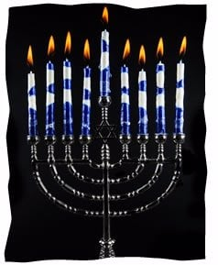

There was always something about lighting a menorah. Even when I was in foster homes as an adolescent, it was something I wanted to do. Maybe it was knowing that my ancestors did the exact same thing, or that millions of people all over the world were staring at the candles too. Or maybe it was just that candlelight is so warming when the ground outside is covered in snow. I’m not sure, but I certainly never expected that lighting a menorah would have any impact on my day-to-day existence.
Nearly three years ago I decided to drop Judaism entirely. I was fed up with the entire venture. The temple I attended was costly and uninviting, not at all what I had expected. There would be no community to raise my daughter with, no traditions to pass on to her. Needless I decided to drop Judaism entirely to say, I was a little bitter about the whole thing.
But, of course, every year I lit a menorah. When my daughter was old enough to appreciate it, I decorated the house with Chanukah flags and garlands, window stickers and crafts. Maybe at some point in her life she too would enjoy the feeling of comfort and safety that I got from the flickering candles.
The temple with which I dropped membership proceedings still sent me a newsletter occasionally, and that year I saw that various synagogues were holding public menorah lightings around the county. A giant menorah! Perfect! I dressed up my little girl in a pretty blue dress and built her anticipation to see a menorah as tall as a tree.
It turned out to be less dramatic than I had hoped—just a few people had gathered to see the lighting. Some homeless men were milling around. There was talk of free latkes and hot drinks in a nearby building afterwards, but as soon as the lighting was over I scooped up my daughter and made a dash for the car. My exodus was interrupted the rabbi. He introduced himself and gave my daughter a little menorah necklace.
“Do you belong to a synagogue?” he asked.
“No,” I replied. The memory of the other temples I had been to, their high fees and constant focus on what my occupation is, rather than who my daughter and I are, made me suspicious of this rabbi. Does this one want twice the cost of my medical insurance for my daughter to play around his children?
The rabbi told me the address of his synagogue. I narrowed my eyes. ”And how much does it cost?”
His face lit up. “This is why I do this,” he said. He told me there were no membership fees. I was astounded.
So, I went to the local Chabad Lubavitch. Yes, it was awkward. There was a definite language barrier, and I often had trouble following the service. But the people were friendly, and I didn’t have to sign a contract to be there. So I went back again, even though going to a Chabad synagogue if you weren’t raised in the world of Judaism is like diving before you learn to swim.
After some coaxing, the rabbi’s wife, Devorah, convinced me to sign up my daughter for Sunday Hebrew school. On the first day, they were having a shofar factory. The smell of power drills running into animal bones and shellac was awful, but my daughter loved it. She looked around wide-eyed at the other kids, made a friend, and was fascinated with the shofar she shellacked. I was sold.
On my way out, the rabbi said to me, “Look what one menorah lighting can do.” I smiled, but didn’t think much of it.
Time has gone by, and now I can’t forget the rabbi’s words. Yes, when I attend a service I still prefer to hide in the kids’ room, where I have some idea what I’m doing (mostly staring at the fish tank), and most of my agnostic-style views haven’t changed, but plenty has. My daughter finished a year in Hebrew school and is learning a new language. She is so proud of all her projects, and so happy with the friends she has made.
Because she enjoyed Hebrew school so much, I enrolled her in the Chabad preschool. She loves her teachers, and I’m glad that she’s in such capable hands. She has developed socially and gained a bit more confidence. After more coaxing from Devorah, she even attended summer camp. So much has changed in our routine, changes that will be there for years to come. She is making memories that she can treasure for life. That is what one menorah lighting can do.

Reprinted from Parshat Mikeitz 5762/2001 edition of L’Chaim

World’s Largest Menorah Lighting at Grand Army Plaza

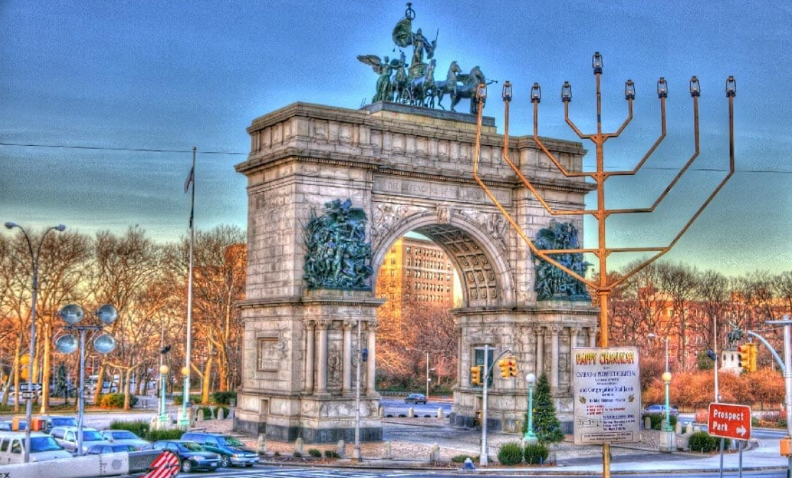

The world’s largest Menorah in Brooklyn (the same size as the other world’s largest Menorah being lit in Manhattan’s Central Park) will be lit every night of Chanukah next to the Grand Army Plaza by Chabad of Park Slope.
On Wednesday night 25 Kislev, December 25th. The first night of Chanukah, the Brooklyn Grand Army Plaza Menorah lighting will take place at 5 P.M. It will be preceded by a concert beginning 4 P.M. starring Nissim Black which will continue after the Menorah lighting until 6 P.M following the Menorah lighting. Chabad of Park Slope will distribute free hot latkes and hot cider to all participating, along with a toy for every child at the event.

The Central Park
Menorah in Manhattan


The other world’s largest Menorah for Jews in Manhattan has been set up in Central Park. It was erected last Thursday and will be lit on Wednesday night by the Lubavitch Youth Organization, headquartered in the Crown Heights section. For schedule of lightings and other details please call (718) 953-1000.

And he said to them: You are spies (Gen. 42:9)
Of all the possible accusations he could level against them, why did Joseph accuse his brothers of espionage? Joseph was afraid his brothers would utilize their visit to Egypt to investigate his whereabouts. By accusing them of being spies, he prevented them from asking too many questions. For no one who is accused of espionage is likely to make too many inquiries about a head of state... (Rabbi Avraham of Pshischa)

Reprinted from Parshat Mikeitz 5762/2001 edition of L’Chaim

